**Bigdata Assignment 5.1**

**Create a Scala application to find the GCD of two numbers.**

**Solution -**

Gcd.scala

object Gcd {

def main(args: Array[String]){

val res = gcd(args(0).toInt,args(1).toInt)

//command line arguments passed to gcd function

println("GCD of "+args(0)+" and "+args(1)+" is "+res)

}

//Gcd function to calculate gcd of 2 nos.

def gcd(a:Int,b:Int): Int = if (b==0) a else gcd(b,a%b)

}

Input – 15 20

Output – GCD of 15 and 20 is 5

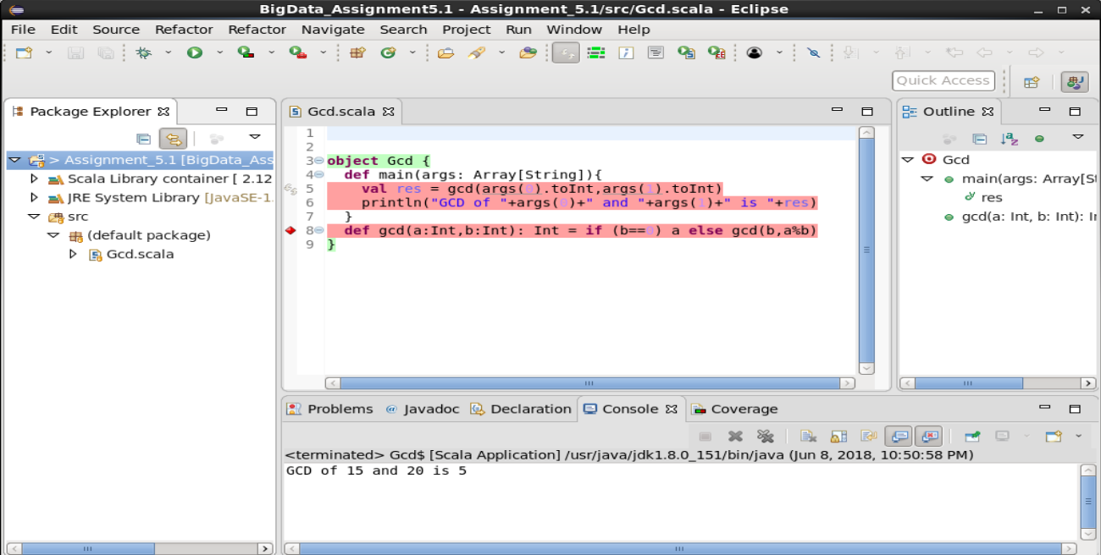

As in the above screenshot it is evident that in the console window ,we got the output , when it was run as a scala application.